**IBM- Naan Mudhalvan Data Analytics with Cognos**

**Phase 4**

**Development Part 2**

**Student Name : Poorni.S**

**Register Number :** 620821104076

**Branch :** B.E CSE

**Year :** 3rd Year

**Topic : DATA** ANAlYTICS WITH COGNOS

**Title :** COVID-19 USING COGNOS

**College :** GNANAMANI COLLEGE OF TECHNOLOGY

**Introduction :**

In the face of the ongoing global pandemic, understanding the intricate patterns and trends of COVID-19 is crucial for making informed decisions. Cognos Analysis empowers us to delve deep into the data, unraveling essential insights that aid in comprehending the virus's spread and its impact on communities worldwide

**Objectives :**

Start building the product sales analysis using IBM Cognos for visualization. Define the analysis objectives and collect sales data from source shared. Process and clean the collected data to ensure its accuracy and reliability..

**Data source**

Dataset is collected from the kaggle.com named “daily-website-visitors.csv” which has a data about the Days, Day of week, Date, page Loads, Unique visits, First-time visits, Returning Visits.

Dataset link https://www.kaggle.com/datasets/chakradharmattapalli/covid-19-cases

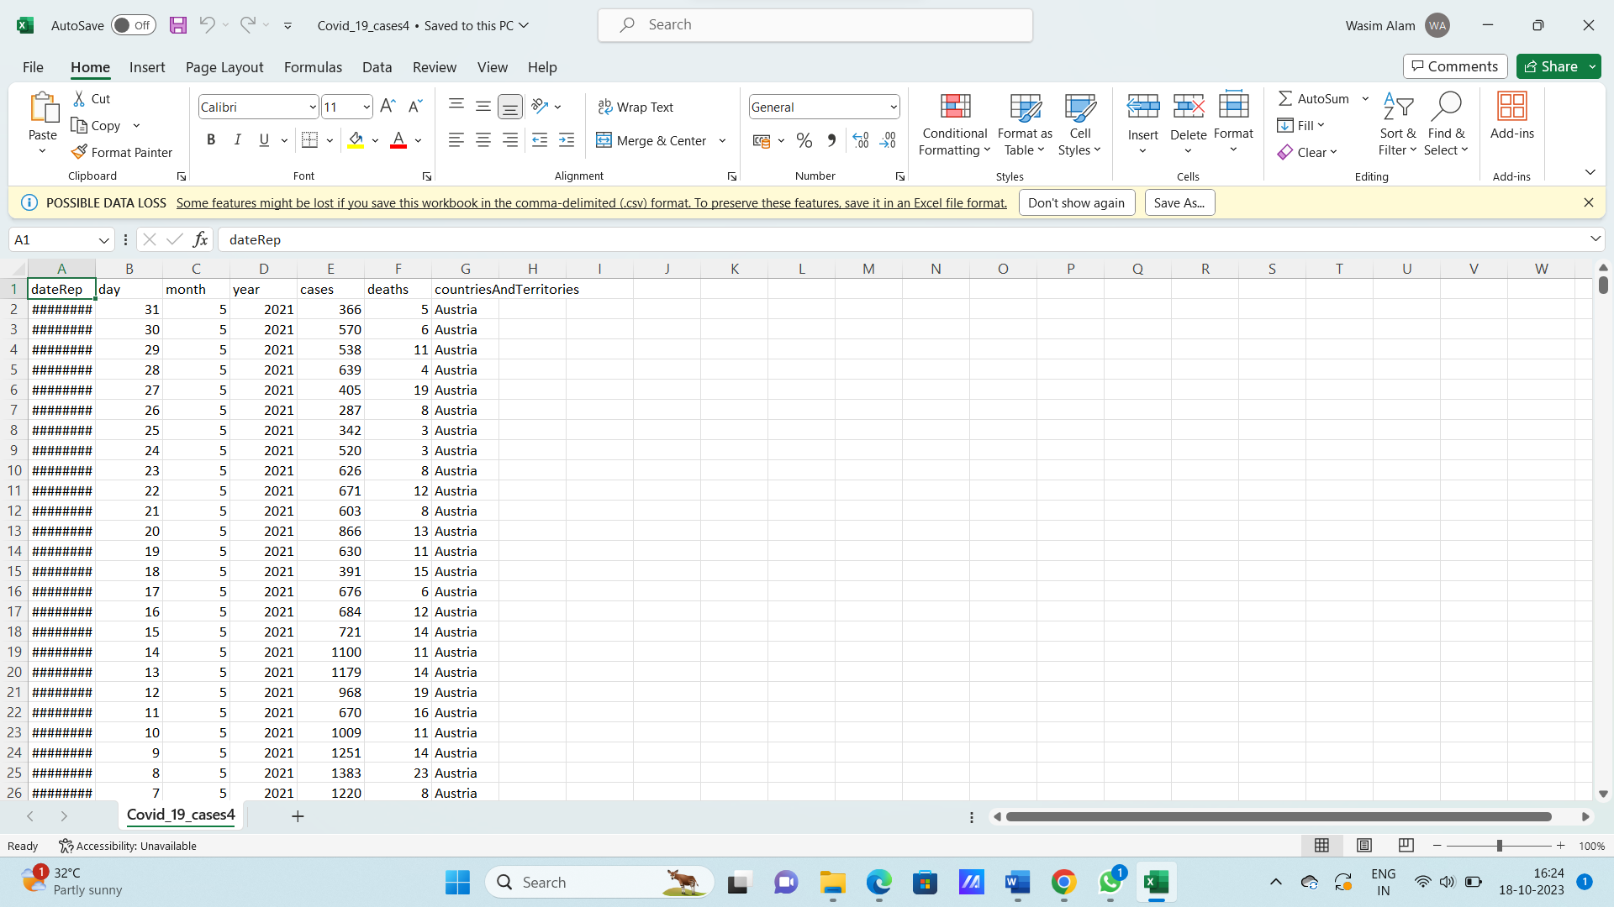

**Data Loading**

Steps Involved in data loading on IBM cognos.

1. **Login to your IBM cognos**
2. **Click more menu from the left side**
3. **Select new tab**

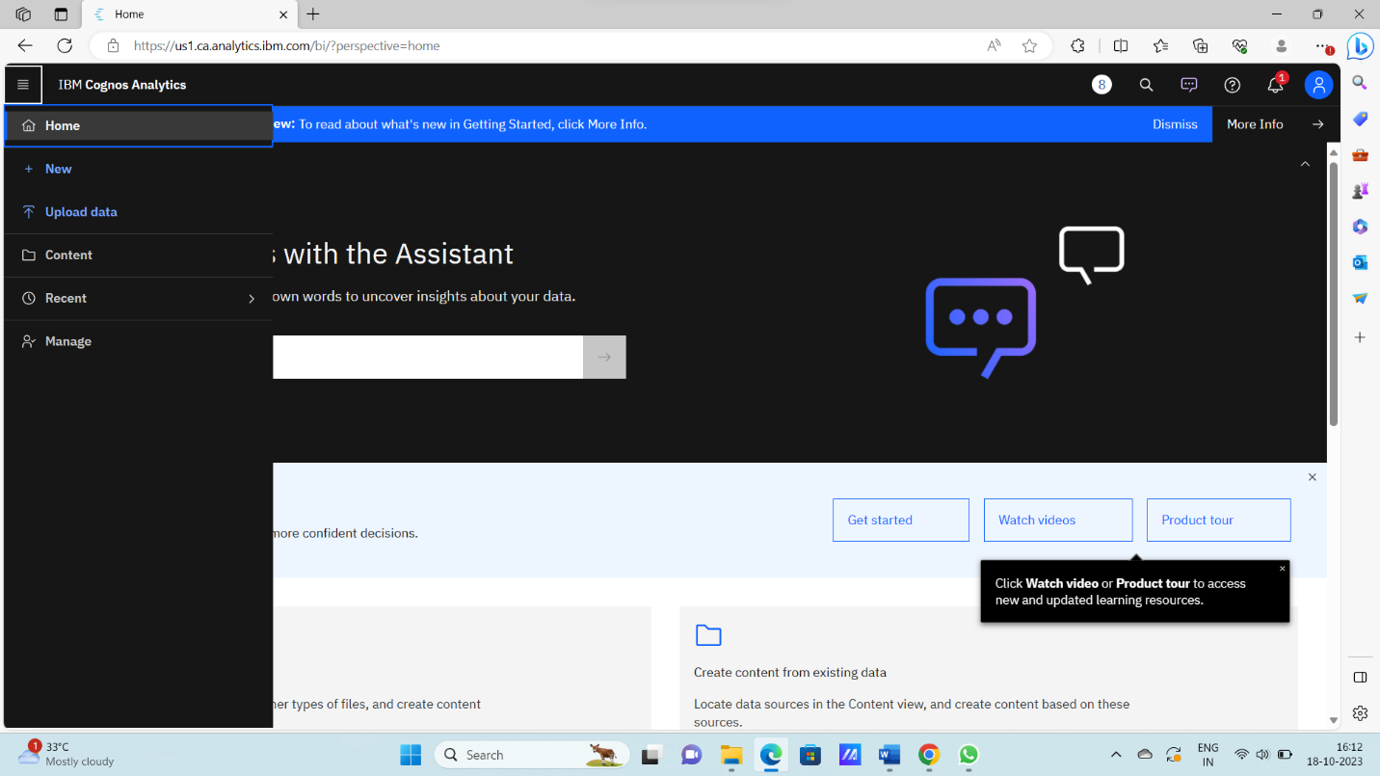

**4. Click Data module tab**

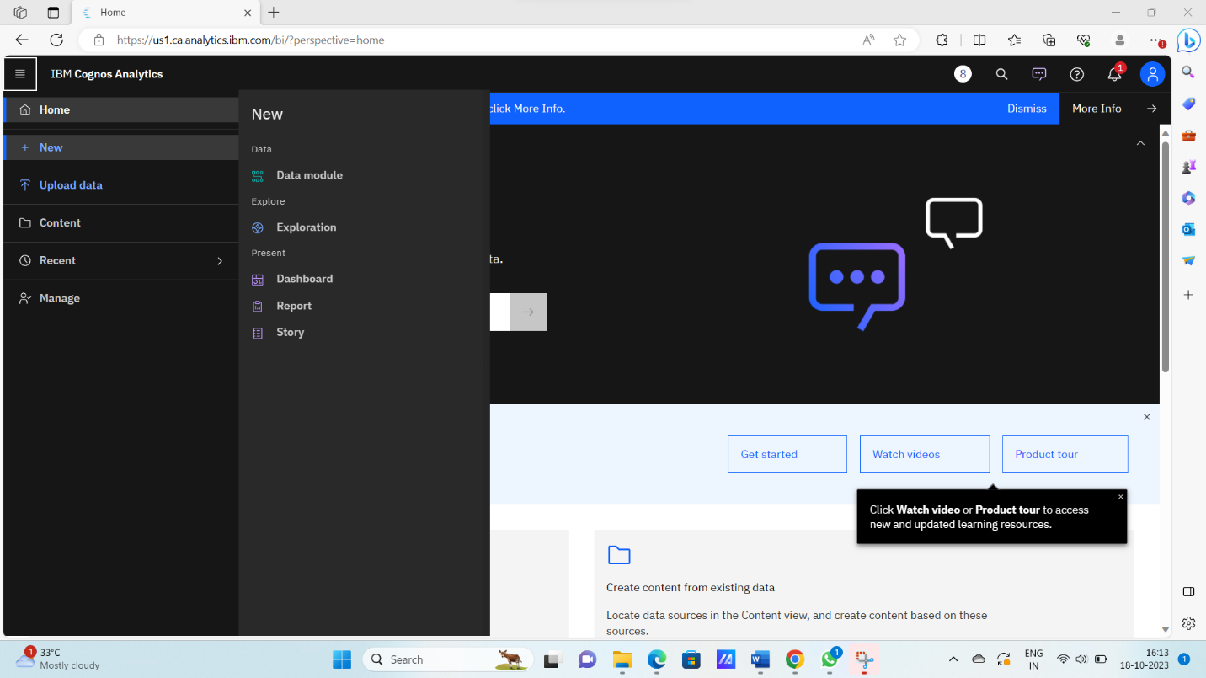

**5.Upload the dataset for your project and select the Corresponding file**

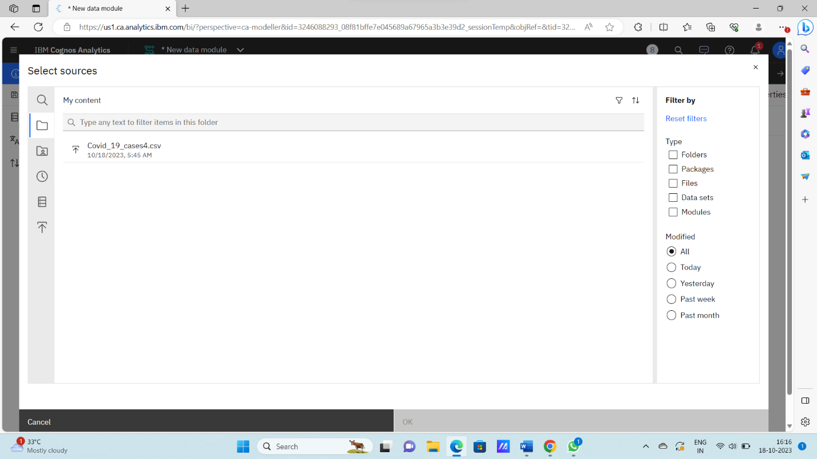

**6. preview the data**

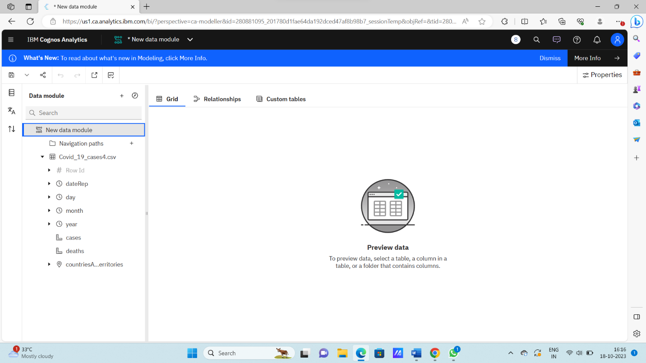

**7.Explore the data**

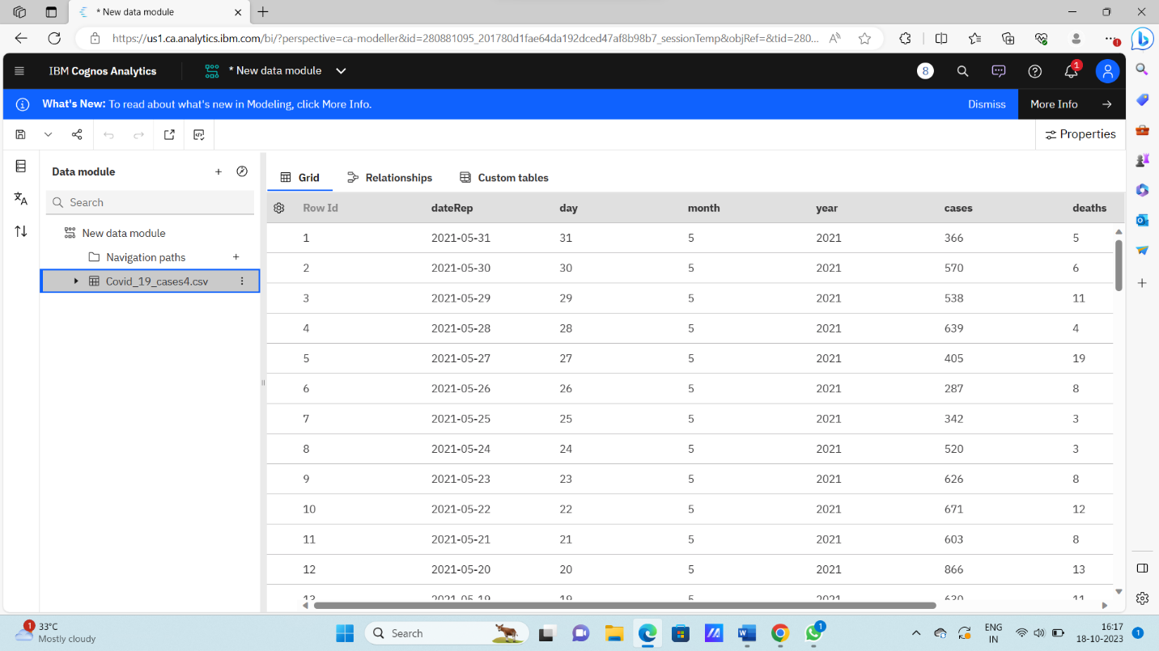

**8. save the data module**

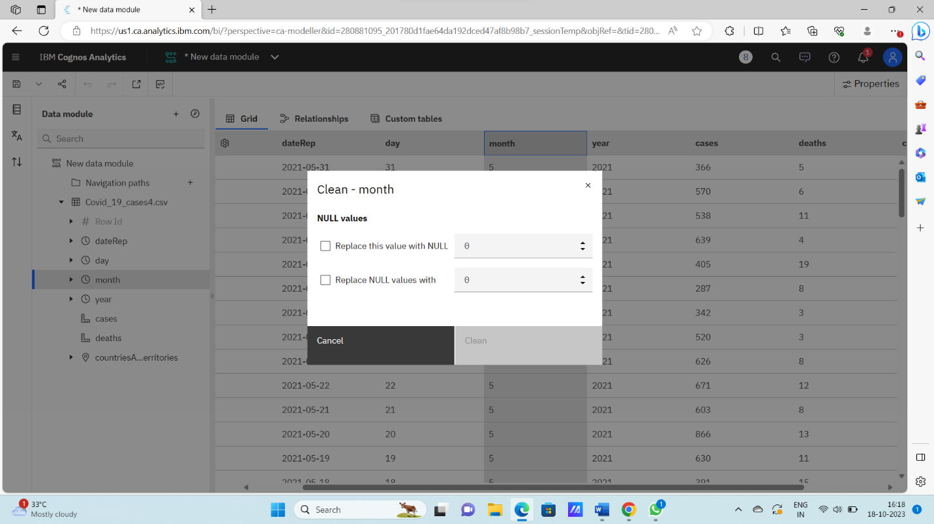

**Data Preprocessing and Cleaning**

In this phase the following steps will taken

* Handling missing data
* Data Transformation
* Data Type Conversion
* Removing Duplicates
* Dealing Outliers

Once you saved the data module. Click the corresponding dataset on IBM cognos and Preview the mosule

Right Click the row where you want to clean the data

It provides the UI to Clean the data and makes the task easy one, Now Updating and Replacing the Null values are simple

data module will be updated by doing the above process

after the completion of process start creating the dashboard for Visualization

**Dashboard Creation**

Dashboard creation are helpful to visualizing the data

1. Goto Home menu
2. Select the new tab
3. Click dashboard



**4. Choose the template for your project and click**

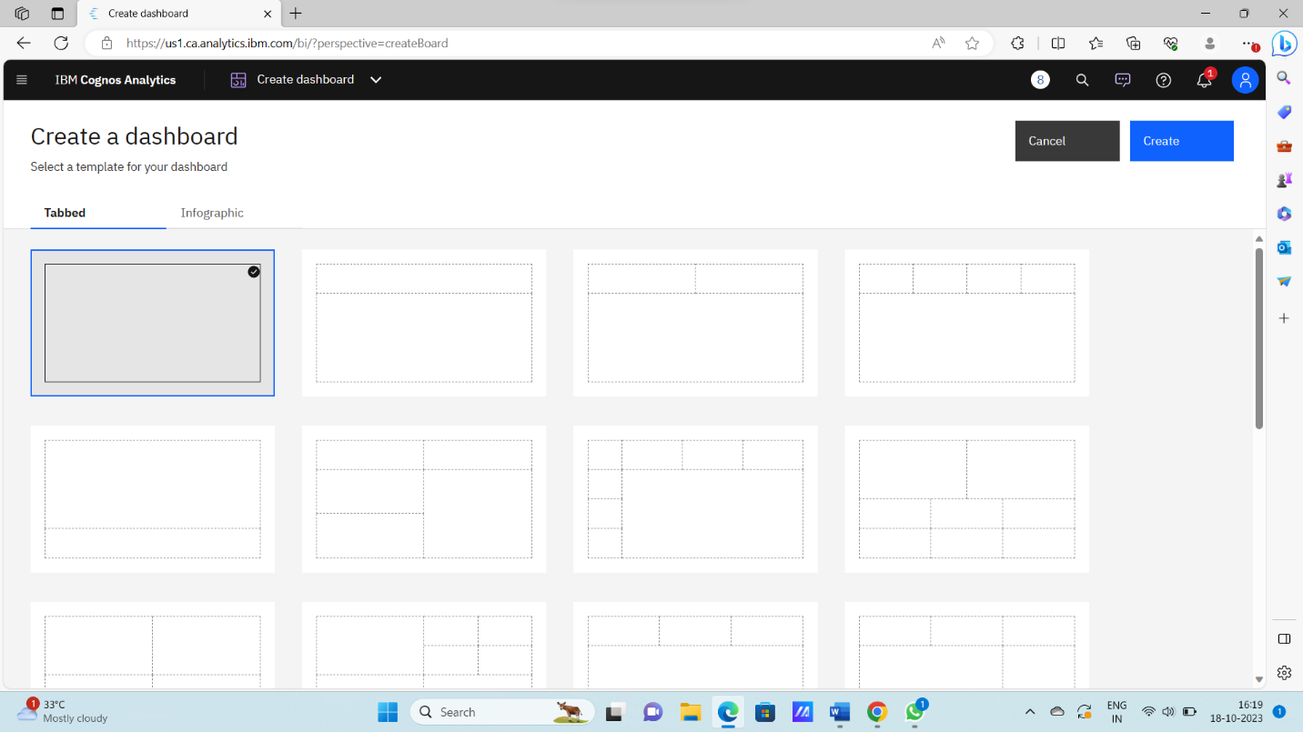

**5.Now Dashboard is created**

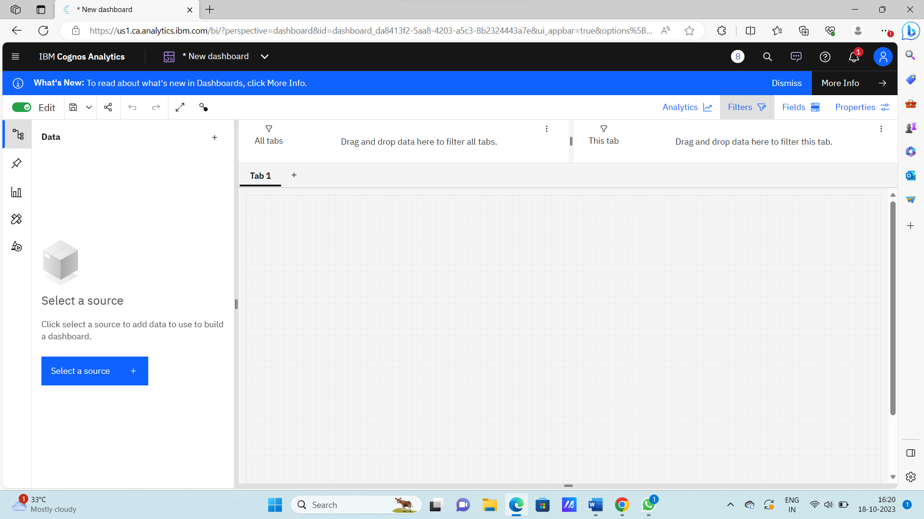

**6. Select the data source**

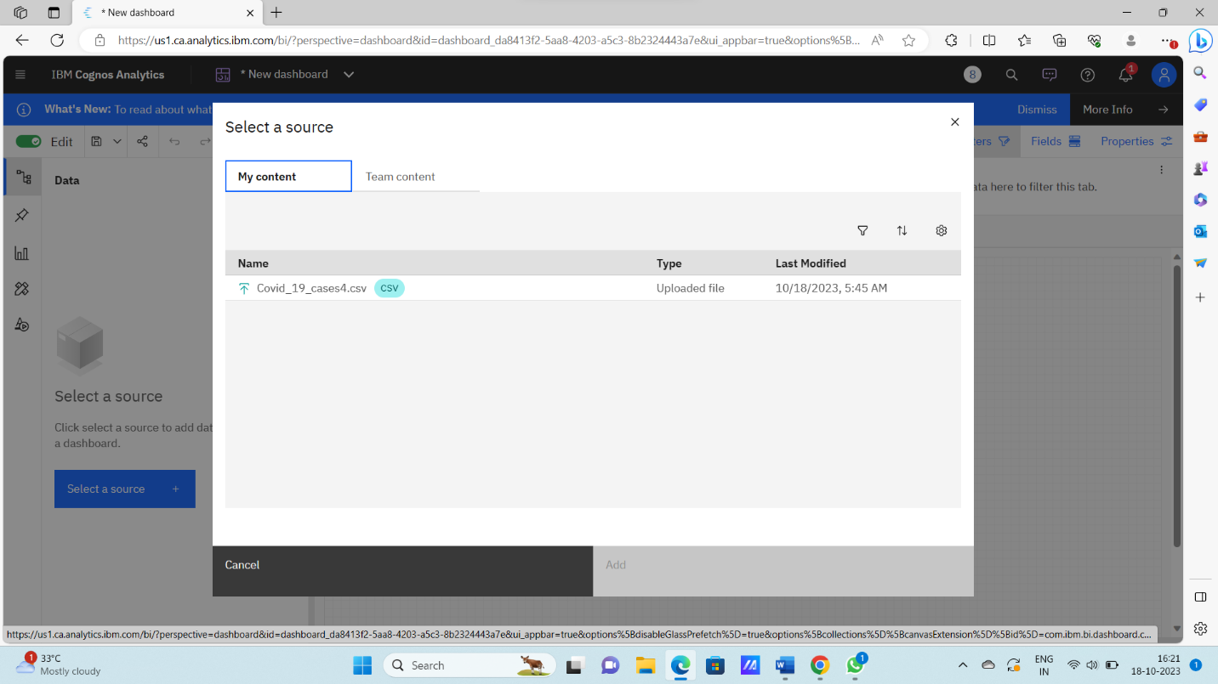

**Visualization :** After creating the dashboard, the next step is to visualize the data

In IBM Cognos

1. Goes to the Corresponding Dashboard

2. select the visualizations tab in the left side of title bar

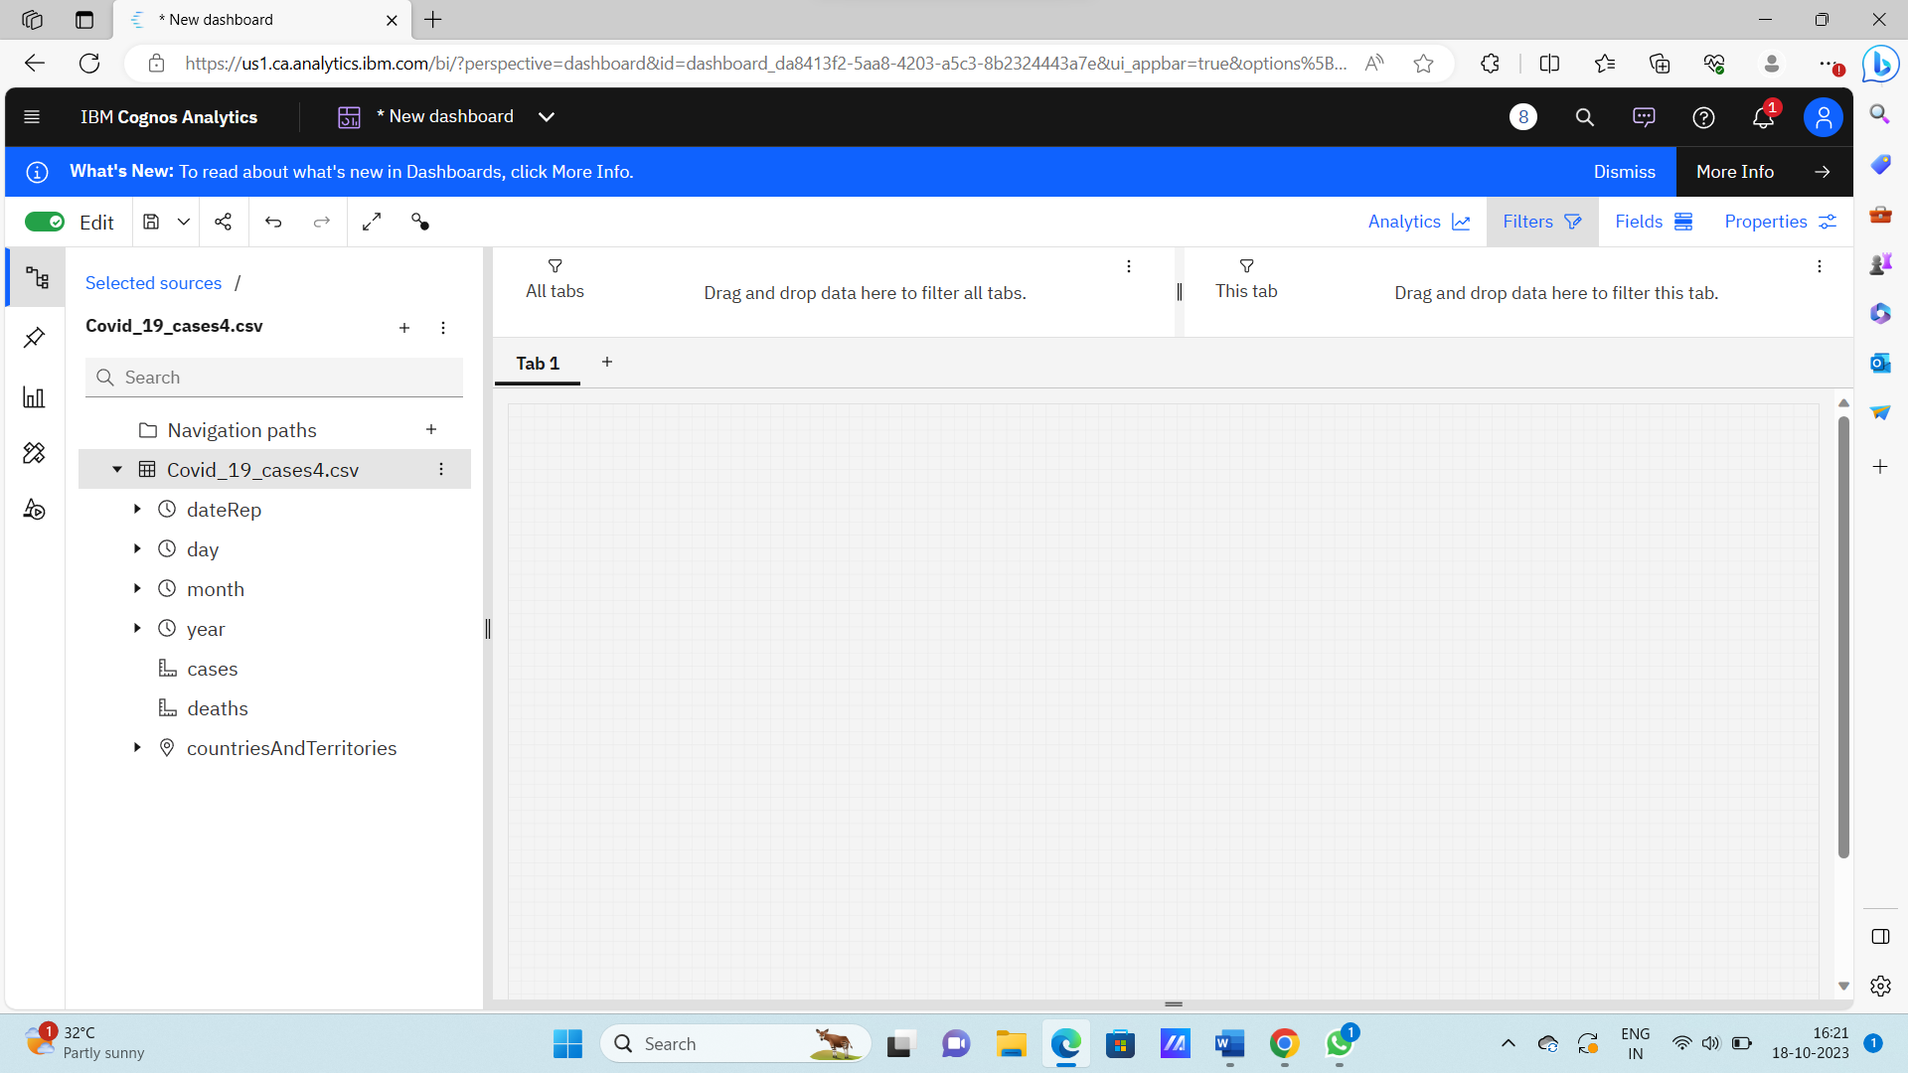

**3.Choose the system as you want and put the data source for the required columns**

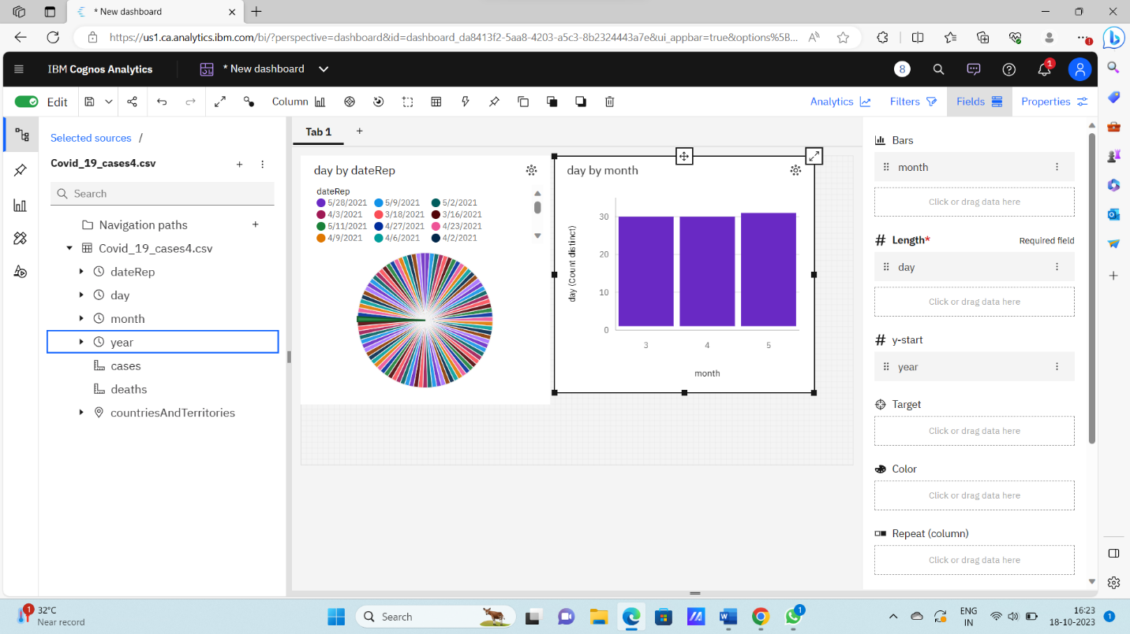

In the above screen shot displays the Pie chart and model compares the “day” and “month” .

X-axis =day

Y-axis = month

After performing these activities a comprehensive document will be created to demonstrate the ability to Communicate and share finding.

7.Code:

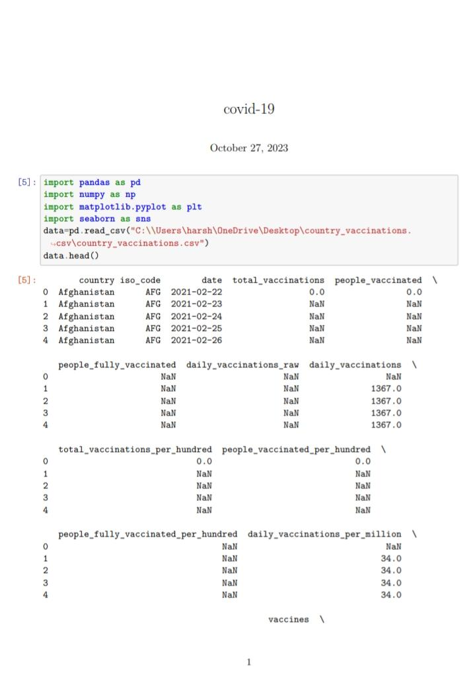

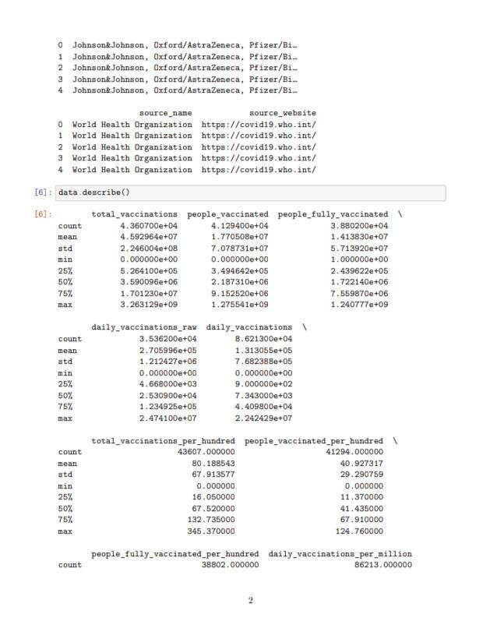

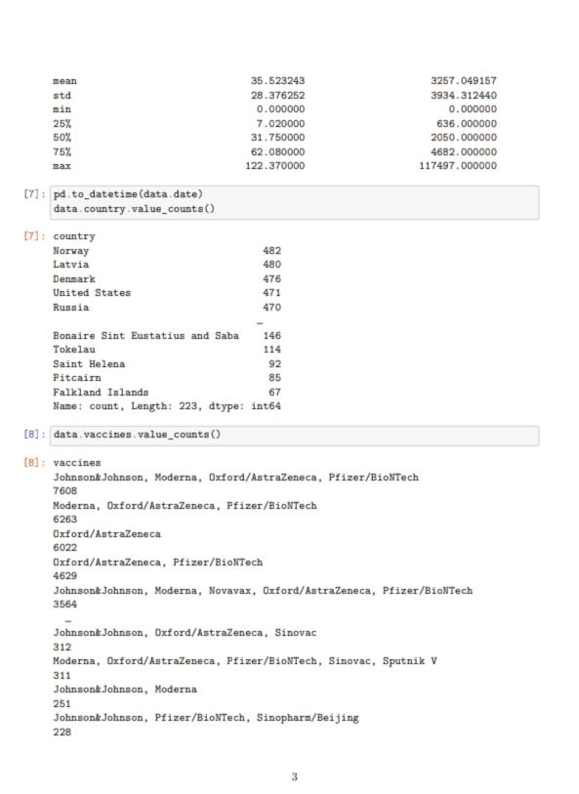

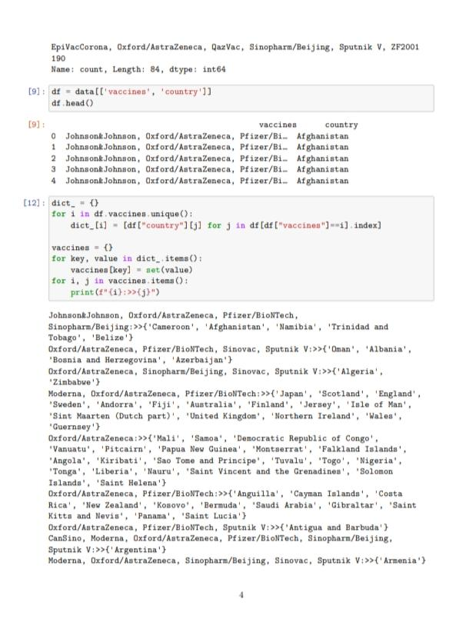

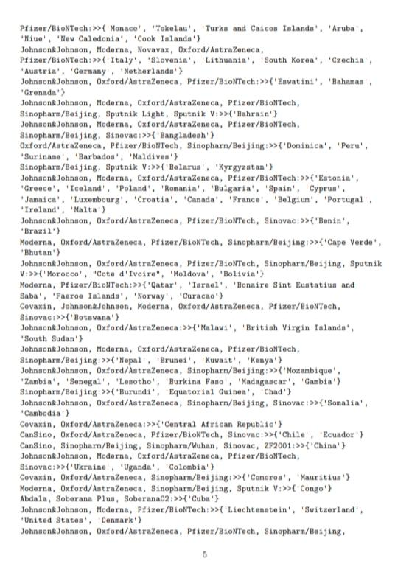

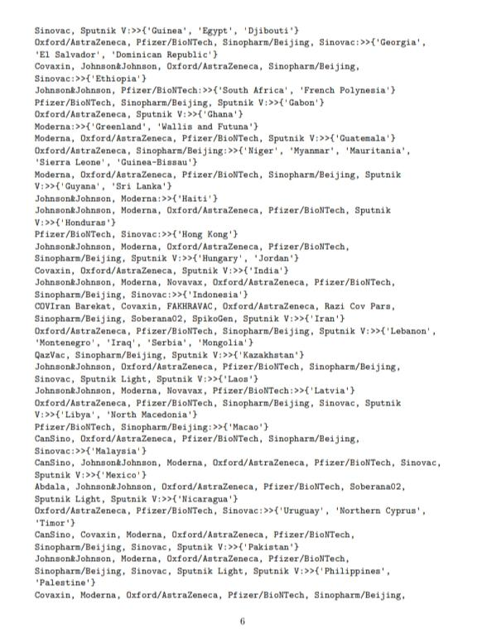

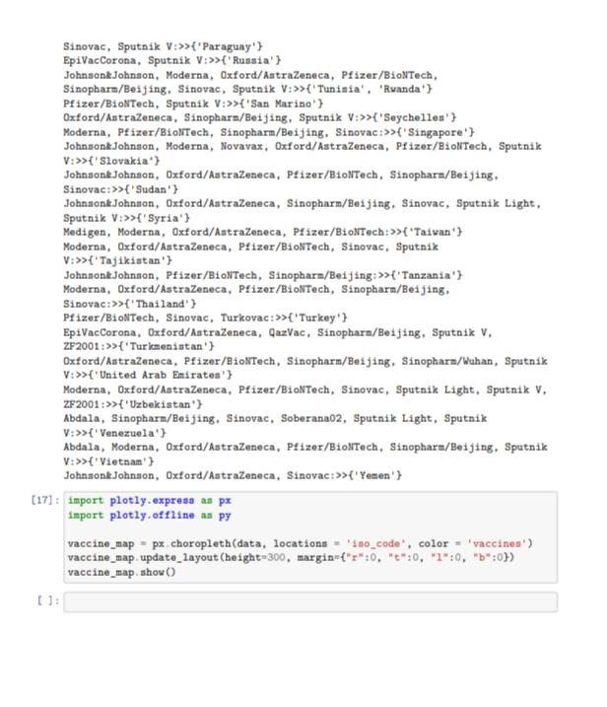

**Conclusion :**

In conclusion, Cognos Analysis has proven to be an invaluable asset in our ongoing fight against COVID-19. This powerful tool has enabled us to dissect complex data, revealing critical insights into the virus's spread, its impact on diverse demographics, and the effectiveness of containment measures and vaccination efforts. By harnessing the capabilities of Cognos Analysis, we are better equipped to make data-driven decisions, allocate resources efficiently, and navigate the challenges posed by the pandemic with greater precision. As we continue to leverage this technology, we move closer to a world where the impact of COVID-19 is minimized, and our communities are better protected.